Foundation 4 Articulate
Abstraction:
Abstraction is one of the most important parts of engineering and invention. The idea is that you can simplify something that is complex. In programming, this is often represented through classes, which allow you to do something rather complex with a few simple lines of code.
My Foundation 1 project has a list of an object called Video. Video contains comments, authors, the video title itself, and other information. All this data is kept within the Video class where its raw form is shown to be relatively complex. This class combined with my other class called VideoLibrary allows the user to easily share lots of the kept data by simply typing “DisplayVideos.”
Below is what DisplayVideos() looks like inside the VideoLibrary class. This function iterates through all the video objects by displaying video titles, authors, and comments left on them.
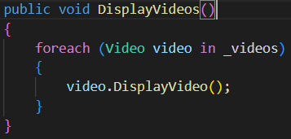
This simple method pulls from and displays many of the Video class objects. Their complexity is shown below:
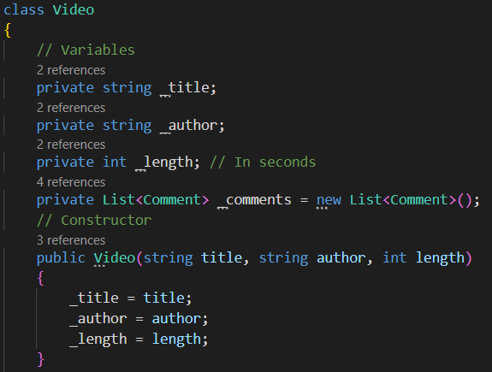
This allows all of the data to be easily iterated and used frequently.

Encapsulation:
Encapsulation is the concept of keeping parts of an object safe in a “capsule” like protection. One thing to keep in mind is that encapsulation comes with protection. Variables can be kept from being changed or seen by other programs and users. We don’t want everybody to change or see the inner workings of our code.
In foundation two, I used this concept to store an store the attributes of my program inside the its original class. The only way they could be accessed is through “set” and “get” methods. These methods prevent other programs from changing or seeing the inner workings of the program. As seen below, each of the attributes is labeled “private.” Below the constructor are methods labeled “public.” With the public attributes, they can set or get the attributes without the attributes leaving the original class.
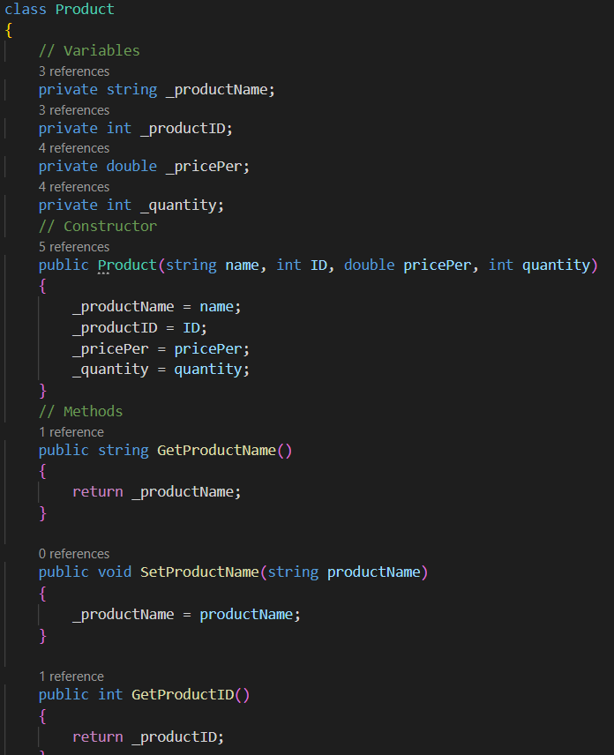

Inheritance:
Inheritance is the ability for multiple classes with some identical attributes to share with a base class. This massively simplifies programming classes and makes it much easier to add to the code and give it additional classes.
In my Foundation 3 program, I had several types of events and all of them had a title, a description, a date/time, and an address. This block of code is one class that contains the shared attributes in it.
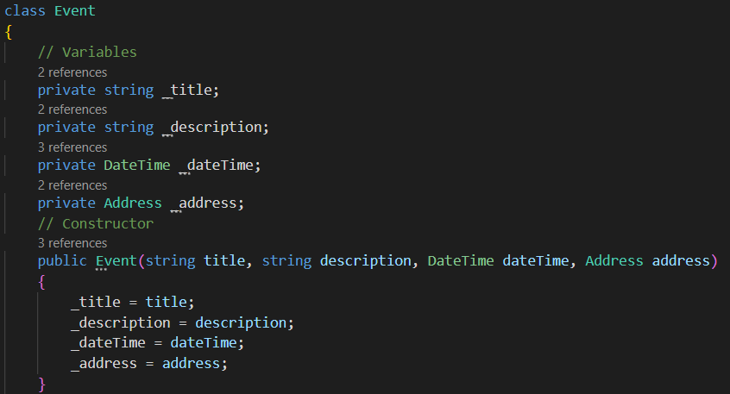
The sub classes (classes for individual and unique events) have these shared attributes. Instead of repeating the code or format in each class, the sub classes inherit from this base class. For the sub classes, they are able to have their own unique attributes. This can be seen below as this lecture class has a speaker and a limited capacity.
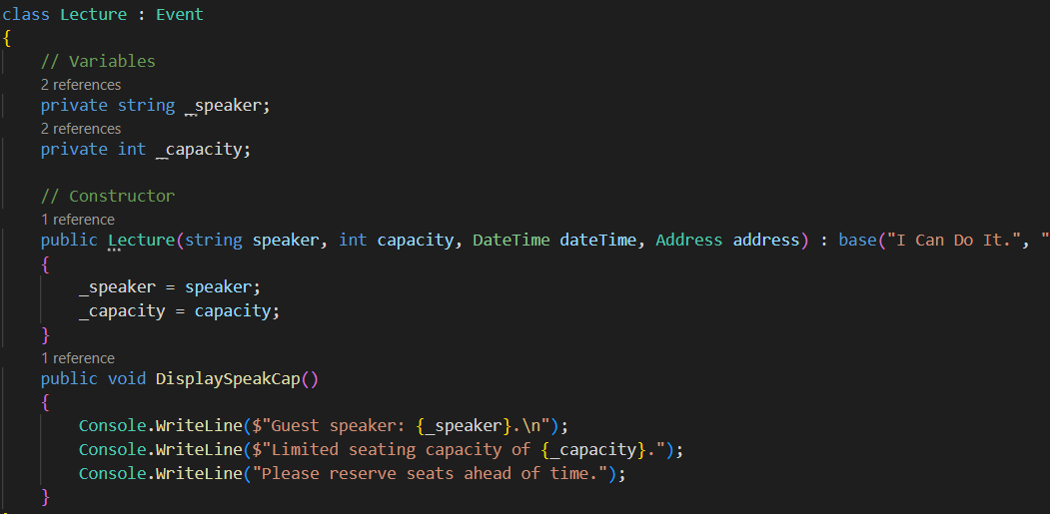

Polymorphism:
Polymorphism has more to do with changing the methods themselves. A program or class to calculate the area of a rectangle is not going to use the same method as a class that calculates the area of a triangle. Polymorphism allows the class to change the base class’s methods to fit its needs.
In my Foundation 4 program, I created an Activity program for a gym, then created three separate classes for each of the activity types. The base class has empty methods that allow the sub classes to morph them to fit individual needs. The base class has three virtual double methods that contain nothing inside them. This can be seen in the picture below:
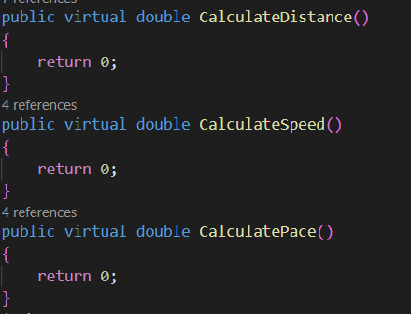
The subclass overrides it and changes how the class method is setup.
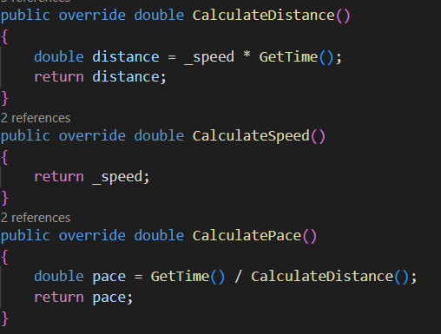
Because this class already had a speed attribute, it could change the ClaculateSpeed method to just return the encapsulated attribute. In another subclass, it uses its own attribute that tracks laps around a pool. To find distance, the method overrides and gives the math needed to calculate the distance the person traveled while swimming. This can be seen here:

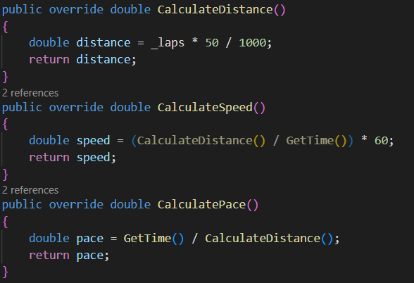

Why this is important:
The use of classes has greatly enhanced my ability to change, rewrite, update, and improve my programs. For my Foundation 4 gym program, I could easily add new subclasses to my base class simply because polymorphism allows subclasses to override methods from the base class. I could add a subclass for Stairmaster, interval training, weightlifting, etc. In my Inheritance Program, I exceeded expectations by adding a new event subclass that inherited directly from the existing Event base class, making the program incredibly easy to expand and improve. By applying abstraction, I can easily hide complex details and only expose what is necessary, allowing me to change the internal workings of a class without affecting the rest of the program. With the use of encapsulation, I can allow change to be simple and protected. With encapsulation you can change portions of code without breaking anything, keeping the program functional as changes are made.

